Page 1 of 4

2013 Summary

I N D U S T R Y R E P O R T
Contents
RETAILING IN
AUSTRALIA’S $3B
FOOTWEAR MARKET
2013 “SNAPSHOT”

Mono and multi brand footwear stores have experienced a decline in business over the past 5 years up to 2003. This downturn has been moderately attributed to low consumer sentiment stemming from macro-economic factors, social, local and global concerns. Retailers have faced a new predicament since the 2008 financial crisis with the consumers increasing savings rates and spending less on discretionary spending which includes the purchasing of footwear. Key external factors that have affected this drop in retail demand also include the ongoing growth of online sales as consumers increasing engage in electronic commerce transactions.

Special Interest Articles

Executive Summary 1

Guest Contributor 2

Online Analysis 3

Article Title 4

Individual Highlights

Inside Story 2

Inside Story 3
Inside Story 4
Inside Story

Given the high labor factor shoes stores usually incorpo− rate, retailers are becoming increasingly frustrated with showrooming, (checking out fit and size before purchasing online). With this trend looking to become larger, some re− tailers are considering charging a nominal amount as a fit− ting charge that can be redeemed against a future pur− chase, this is commonplace in ski stores that sell and hire ski boots. The industry is also faces strong external compe− tition from chemists, clothing retailers and department stores that also offer footwear and compete for the same dollar with traditional mono−product footwear retailers. Department stores have been a growing threat to specialty retailers in most cases stocking a boarder range of product while offering the consumer new levels of value driven brand name footwear product.
Page 1 of 4

Considering this, revenue is expected to contract by more than 4% in the calendar year ending 2013, as the industry is plagued by concerns of international competition entering the market, which is having a direct impact on profit for the locally run traditional family shoe store. International brands such as Novo (90 Stores) and ALDO have managed to make large inroads targeting the fashionable and value for money market.
RCG Corporation continues its success of the Athletes Foot chain and continuing to roll out its Bigfoot concept stores in− corporating an impressive representation of walking and school shoes. Despite the recent unsustainability and selling off of it’s Shoe Superstore concept, RCG has still carved out more than 8% market share.
Page 1 of 4

Page 2 of 4

Growth Challenges in 2013/14 – Stock Control and Discounting…

Page 1 of 4

Despite external challenges; (international and national) having a significant impact on the day to day running of a footwear businesses, management of stock control seems to be an ongoing challenge for the market.

Another area of concern for the industry is inventory dis− counting being led in part by department stores. Brand name importers in search for growth and recognition often see department stores as stability through num− bers.

In addition to this, many importers have recently seen minimum factory quantities and general prices of im− ported product dramatically increase. Some have opted to hold passing on these increases in an attempt to keep RRP’s consistent.

However some importers have had no choice than to pass prices rises on to retailers. Whether retailers will see fit to pass on these increases on to consumers will remain to be seen.

“One store in particular on the NSW Central Coast is now taking almost 50% of their weekly sales online”

Industry professional – Opinion Piece
Did you know?

Did you know almost 50% of all
footwear sold in Australia is to
women?

Parents are spending more on
higher quality end fashionable
children’s shoes than ever
before?

Over 40% of footwear sold in Australia is sold to 35-54 YO’s?

Wages now typically account for
17% of turnover and are the 2nd
highest expense after rent!
Did you know?

Did you know almost 50% of all
footwear sold in Australia is to
women?

Parents are spending more on
higher quality end fashionable
children’s shoes than ever
before?

Over 40% of footwear sold inn Australia is sold to 35-54 YO’s?

Wages now typically account for
17% of turnover and are the 2nd
highest expense after rent!

John Mansour – Manning Shoes (5 Stores)


Dealing with Digital

As independent Australian Footwear retailers witness an almost changing of the guard” some stores are using their tenacious and determined minds at taking on the titans of online footwear in a seemingly level playing field. One store in particular on the NSW Central Coast is now taking almost 50% of its weekly sales online. This store places a great deal of effort and funds into SEO (Search Engine Optimisation) development and is ex− tremely adept at delivering a quality service to its online customers. A staggering 60% of online business is a re− turning customer.

In International news, The Iconic.com.au spanning a cat− egory of over 45,000 products including footwear has recently secured additional funding to the tune of $28M from an investment house which has been considering making a sizeable investment in the online pure play for some time. In older news Styletread.com.au has also been sold off recently for a fraction of the funds that has been sunk into the business to stabalise the business and prepare it for growth. International players such as ASOS opened an Australian subsidiary in 2011 and have many fashion and footwear brands as well as their own vertical product. Free shipping and a large range of footwear also entice the offer for the consumer.
Customer Service Implementation

Embracing an online strategy has also come as a clear move from footwear importers − Pacific Brands (Hush Puppies) and Cadet Footwear (Zensu) in launching their online plaVorm direct to consumer. Many retailers view this as direct competition while some viewing it as in− creasing brand exposure and an evolutionary process of the digital era.
Best Foot Forward

Barlan is a niche organization dedicated to footwear service excellence.

We the leading organisation in assisting in the development of footwear stores to implement disciplined customer service practices that enable mono and multi brand footwear retailers to become increasingly customer focused, customer-active and profitable.

In building brand loyalty, it is our solid belief that strong engagement practices lead to higher conversion rates.

If your staffs have a desire to sell the story that separates your brand from the generic footwear experience, customers not only purchase, they have a desire to be part of that story.

Workshop options are assessment based and give individual and group assessment scores. This gives us measureable results from an individual competency level as well as a group competency score.

From this, employers are able to oversee, measure and manage the competency level of your retail workforce and place emphasis on improving the overall core competency of your front-line people.

www.barlanconsulting.com.au

Best Foot Forward

Barlan is a niche organization dedicated to footwear service excellence.

We the leading organisation in assisting in the development of footwear stores to implement disciplined customer service practices that enable mono and multi brand footwear retailers to become increasingly customer focused, customer-active and profitable.

In building brand loyalty, it is our solid belief that strong engagement practices lead to higher conversion rates.

If your staffs have a desire to sell the story that separates your brand from the generic footwear experience, customers not only purchase, they have a desire to be part of that story.

Workshop options are assessment based and give individual and group assessment scores. This gives us measureable results from an individual competency level as well as a group competency score.

From this, employers are able to oversee, measure and manage the competency level of your retail workforce and place emphasis on improving the overall core competency of your front-line people.

www.barlanconsulting.com.au

The big question lies in the southward trend of the Aus− tralian dollar where an international purchase from yes− terday, may not seem as financially appealing. Conve− nience of mobile shopping and home delivery and ease of returns will see growth in domestic online purchases.

Page 3 of 4

Page 4 of 4

Australia’s footwear market v’s Asia Pacific
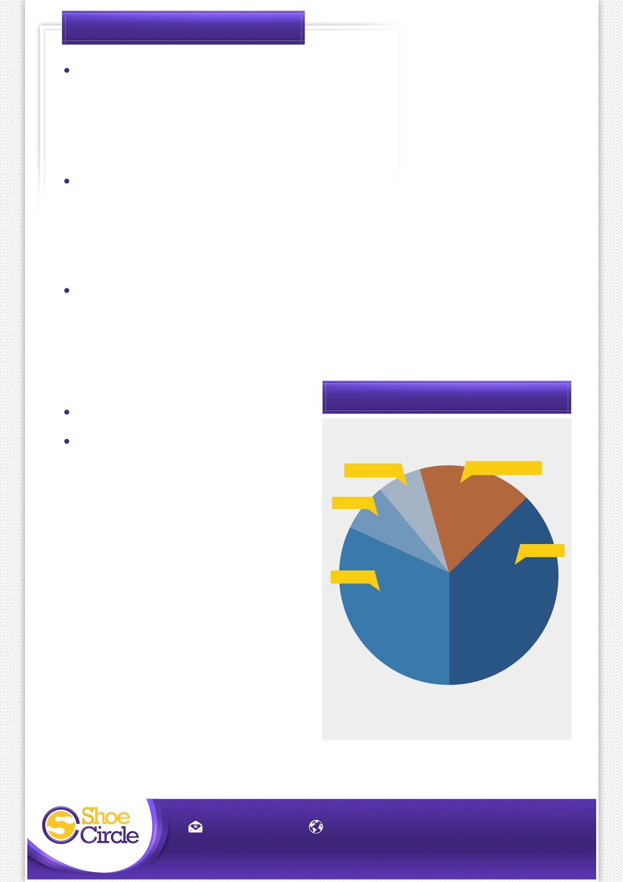
Habits of Successful Footwear Retailers

A Clear and Concise Market Position
Make certain people can identify what your store represents whether it be high volume or niche product. Make sure to make this message as clear as possible. In recent time many family run shoe stores are opting not to sell children’s footwear due to it’s high labor, low return nature.
Active Product Merchandising
Reinforcing your position through the display of in-store presentation and attractive window displays plays a large part for taking the customer from being a window shopper to trying a pair of shoes on in store. It is a huge draw card in enticing customers to purchase.
Trained Store Staff
Product knowledge, sincere service and sales all go in hand. With the internet also playing as a great research tool, customers can sometimes enter retail stores with arsenals of knowledge it is imperative if your product has a technical aspect that your staff be the authority on the brand or your product unique selling features.
Stock Turn Funding
Digital Strategy

Australia

Rest of Asia-Pacific

S.Korea

16.9%

6.0%

7.8%

China

Japan

31.6%

37.8%

EMAIL ADDRESS WEBSITE
mail@shoecircle.com.au www.shoecircle.com.au

facebook.com/shoecircle | twitter.com/shoecircle | foursquare.com/shoecircle

